WEB APPLICATION : e-Store

INTRODUCTION
The eStore Web Application is a lightweight and user-friendly web-based solution designed for modern retail businesses. It allows efficient management of e-commerce operations across the domains of inventory control, billing, and customer interaction. Beyond its simplicity, the application enables the digital transformation of small and medium businesses by automating traditional processes
OVERVIEW
The primary goal of the eStore project is to create a scalable and efficient web-based system for:
- Customer Interaction through the Home (Index Page).
- Billing Transactions through the Bill Management Page.
- Stock and Inventory Management via the Inventory Tracking Page.
The application serves as a stepping stone for businesses transitioning into the online retail space, ensuring smoother operations, better visibility, and a modern customer experience.

LIVE SITE: https://hrudya746.github.io/webApplication_eStore/index.html

1. Homepage (index.html)
The index.html page serves as the entry point of the application and provides a user-friendly interface for customers and users to interact with the bakery's web application.
Features:
- Acts as the storefront for customers to navigate the other functionalities.
- Provides an organized and professional landing page with easy access to modules such as billing and inventory management.
Business Purpose:
- Enhances the business's online visibility, allowing it to appeal to a broader audience.
- Simplifies navigation for users by acting as a central hub for the application’s functionalities.
- Sets the stage for a modernized digital presence, helping the small bakery adapt to digital trends.

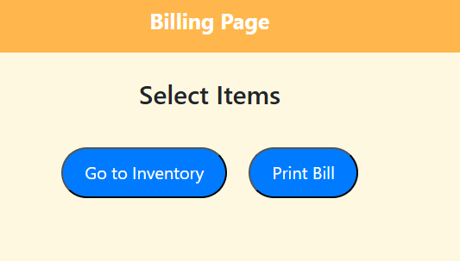

2. Billing Page (bill.html)
The bill.html page is the most critical component of the application as it facilitates fast and accurate billing for customers.
Features:
- A simplified interface where employees can input purchased items and quantities.
- Automated calculations of pricing, total costs, taxes (if applicable), and final bill amounts.
- Displays real-time computed outputs to avoid manual calculations.
Business Purpose:
- Minimizes errors typically caused by manual billing processes.
- Drastically reduces the time spent generating bills, which is especially important during peak hours when staff must serve multiple customers efficiently.
- Improves the customer experience by ensuring faster checkouts and fewer delays.

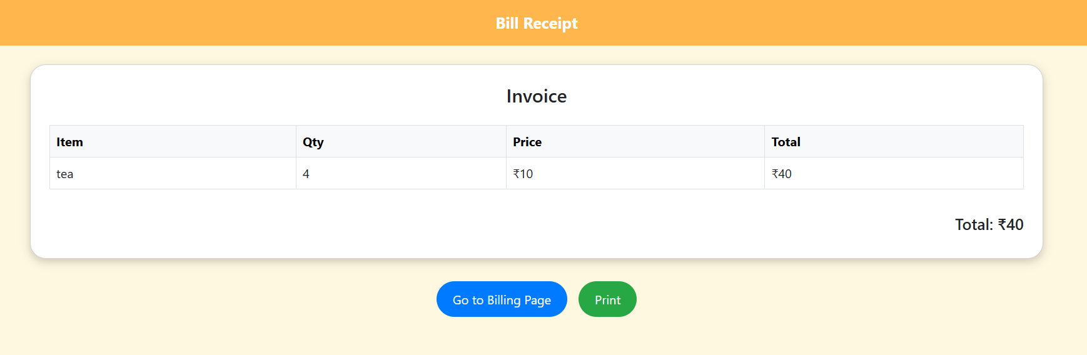

3. Inventory Management Page (inventory.html)
The inventory.html page is designed to assist the business in effectively managing stock levels and avoiding issues like overstocking or running out of inventory.
Features:
- Displays the current list of products along with available stock quantities.
- Allows users to manually update inventory, ensuring accurate tracking at all times.
- Provides insights for better stock replenishment decisions.
Business Purpose:
- Reduces operational inefficiencies caused by inaccurate inventory records.
- Helps the bakery plan its stock levels more effectively, preventing situations where popular items are unavailable during high demand periods.
- Lays the foundation for future integration with automated replenishment systems.

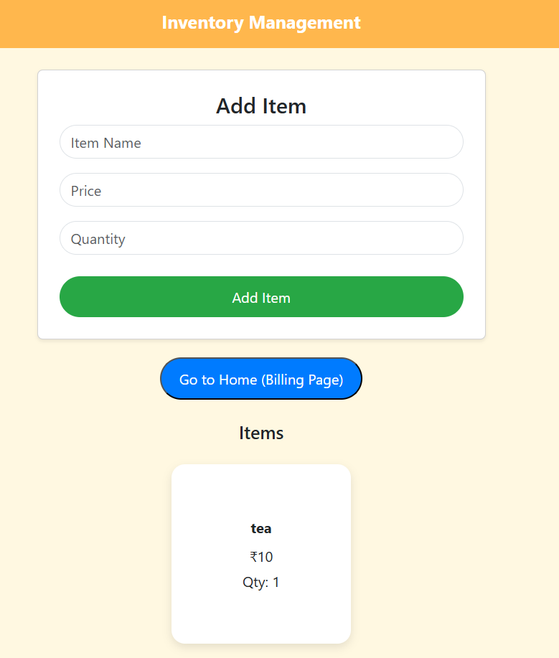

Limitations
While the application achieves its primary goal of simplifying operations for the Iyengar Bakery, it does have some limitations in its current state:
- No Backend or Database Integration:
The application lacks a database to store billing and inventory data. All data is manually updated and not persisted across sessions.
- Limited Scalability for Large-Scale Operations:
As a static website, the system may not handle large datasets efficiently or support multiple concurrent users.
- No Authentication System:
There is no differentiation between user roles, such as admin or cashier, which could pose security risks in broader implementations.
- Basic UI/UX Design:
The user interface is minimal and lacks advanced design elements that could enhance user interactivity.
- Lack of Real-Time Functionality:
Due to the static design, the system does not support live data updates for inventory or billing processes.

Scalability for Future Enhancements
The modular design of the eStore application allows for several future improvements to overcome its current limitations and enable greater scalability:
- Database Integration:
Adding a database such as MySQL or MongoDB would allow for real-time storage and retrieval of billing transactions and inventory data, enabling a dynamic and robust application.
- Authentication and Role-Based Access Control:
Implementing secure login systems and differentiating roles (e.g., Admin, Cashier, Customer) would enhance security and facilitate role-specific functionalities.
- Cloud or Server Integration:
Hosting the application on cloud platforms like AWS or Azure, along with backend support using Node.js or Python (Django/Flask), would make it more scalable and global.
- Improved Inventory Management:
Adding features like low-stock alerts, automatic stock level deduction on sale, and analytics on stock usage trends would make the inventory system more advanced.
- Advanced UI/UX Design:
Upgrading the application’s design to make it mobile-friendly and visually appealing would cater to a broader range of users.
- Integration with External APIs:
The application could integrate with APIs for payment gateways like PayPal or Razorpay, making online transactions seamless.

Business Impact
This web application provides significant benefits to the Iyengar Bakery:
- Operational Efficiency: By automating billing and inventory processes, the bakery has drastically reduced time wasted due to manual operations.
- Peak Time Management: The bakery can now manage larger customer volumes without compromising on service quality.
- Error Minimization: Computational errors are reduced, leading to greater customer trust and fewer accounting discrepancies.
- Foundation for Growth: The app lays the groundwork for the business to expand into a fully-fledged e-commerce operation in the future.

Conclusion
The eStore web application is a clear example of how simple technological tools can have a powerful impact on small-scale businesses. Through its index.html, bill.html, and inventory.html pages, it enhances operational efficiency, especially during peak hours, and enriches the customer experience.
Despite its limitations, this project has demonstrated the practical application of essential web development techniques to address real-world retail challenges. By addressing these limitations in the future, this system has the potential to evolve into a comprehensive retail management solution, enabling small businesses like the Iyengar Bakery to thrive in a competitive market. It showcases how digital transformation, when applied thoughtfully, can revolutionize even the simplest of businesses.

